**Advanced Analytics of Finance**

**Problem Set 3**

**Elina Harutyunyan**

**Question 3**

**Part A**

Below are the scatterplots of managers’ monthly excess returns against the market excess returns:

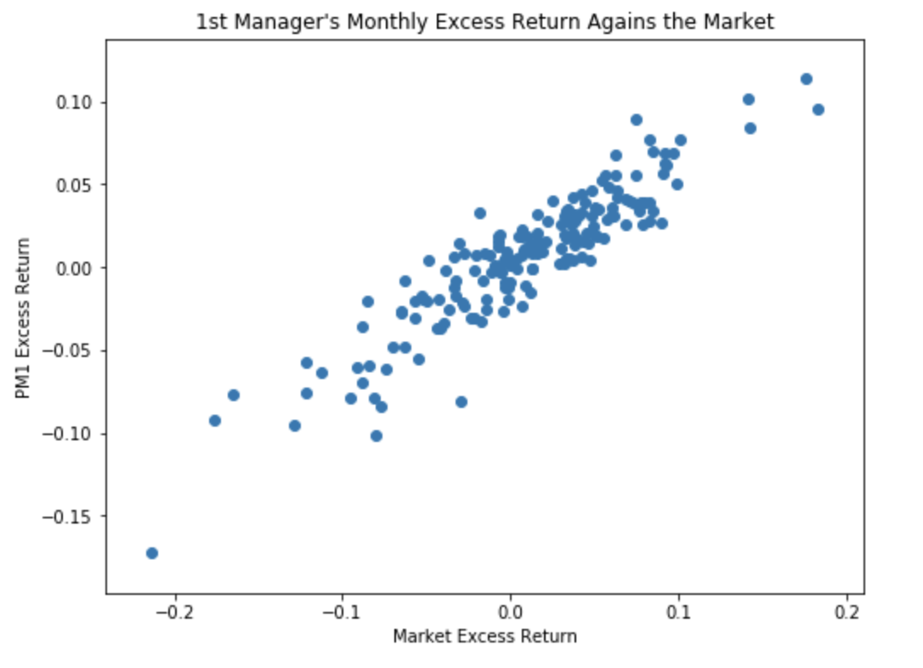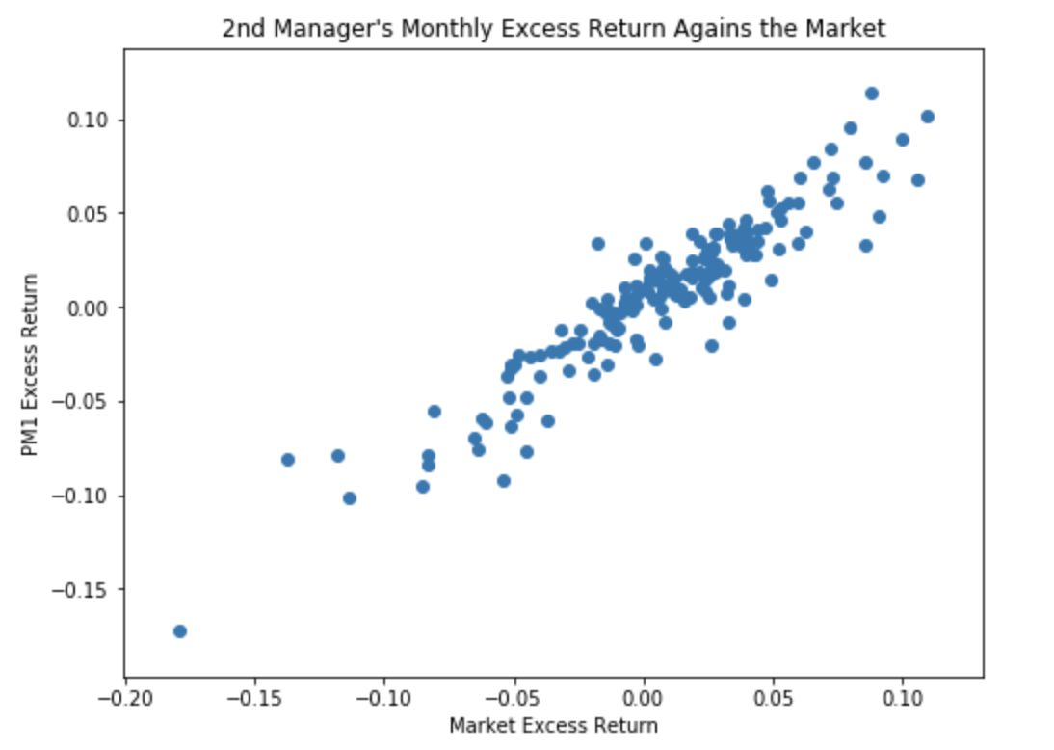

As we can see, both managers’ excess returns are positively correlated with market excess returns, however for the second manager, the excess monthly returns are more concentrated towards being higher compared with the first manager.

To explore even further, we plot the boxplots of managers’ monthly returns:

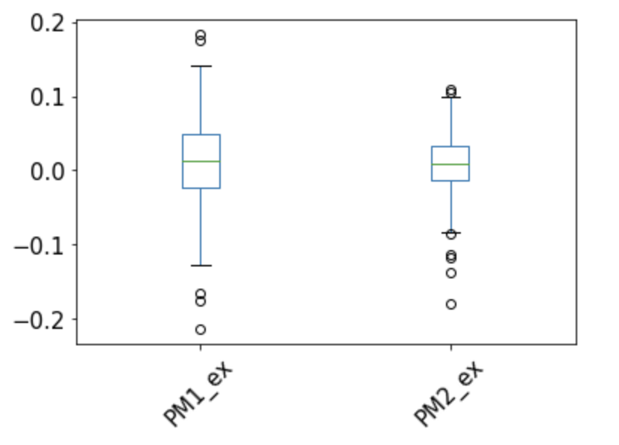

We can observe, that the median returns of both managers are very close to each other and there are some outlier excess returns for both of them, however for the second manager the outliers seem to be more on the negative side. In general, we can deal with these outliers by winsorizing them, in other words those excess returns in that are higher in magnitude than median ± 3.5*Interquartile Range would be change to equal that amount.

|  |  |  |  |  |  |
| --- | --- | --- | --- | --- | --- |
|  | Mean, % | St. Dev, % | Sharpe Ratio | Information Ratio | Maximum Drawdown |
| Manager 1 | 12.309 | 21.088 | 0.584 | 0.377 | 53.489 |
| Manager 2 | 8.553 | 15.398 | 0.555 | -0.006 | 56.322 |

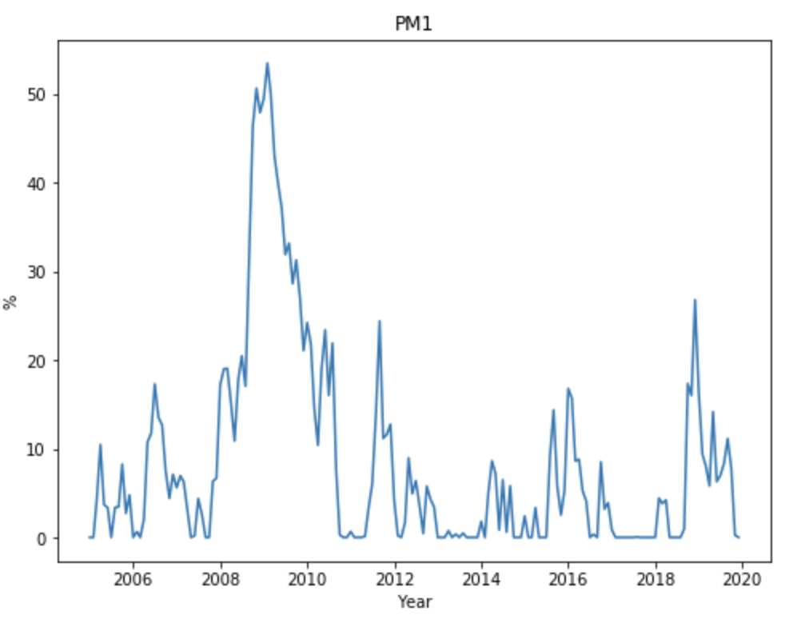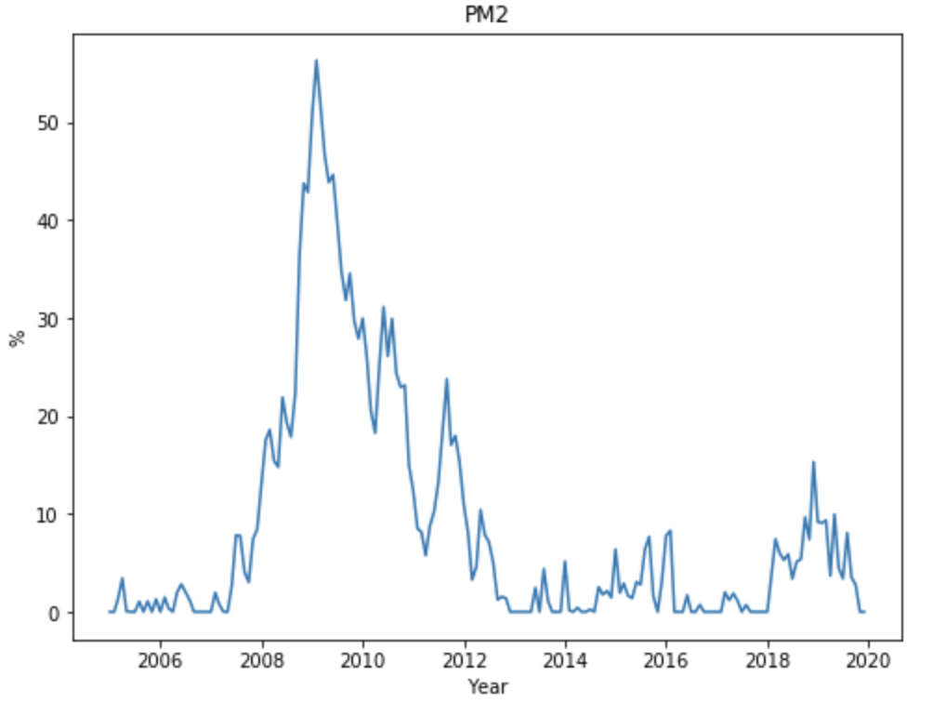

The table above reports annualized mean, standard deviation Sharpe Ratio and Information Ratio of both managers, as well as the maximum drawdown during the period from 2005 to 2019. As we can observe, the first manager has both higher average excess returns and higher volatility, however the volatility is not as high compared to the excess returns hence the Sharpe ratio of the first manger is higher as well. In addition, the information ratio is higher for the first manager and maximum drawdown is lower, meaning that the first manager outperforms the market for the given amount of tracking error, however the second manager underperforms the market.

**Part B**

In order to understand if any manager has the ability to outperform the market and generate alpha that is significant for our sample time period we perform regressions for each of the managers excess returns:

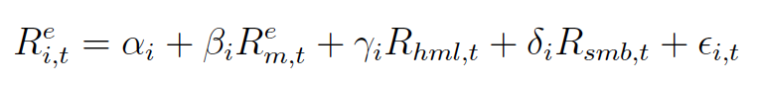

The result of this regression for the first manager is reported below. As can be seen, the alpha is negative but close to zero and not significant, whereas all the market and Fama French factors are significant at a 1% level. The coefficients on the market and SMB factor are positive, whereas it is negative for the HML factor, suggesting that HML is not part of this managers strategy.

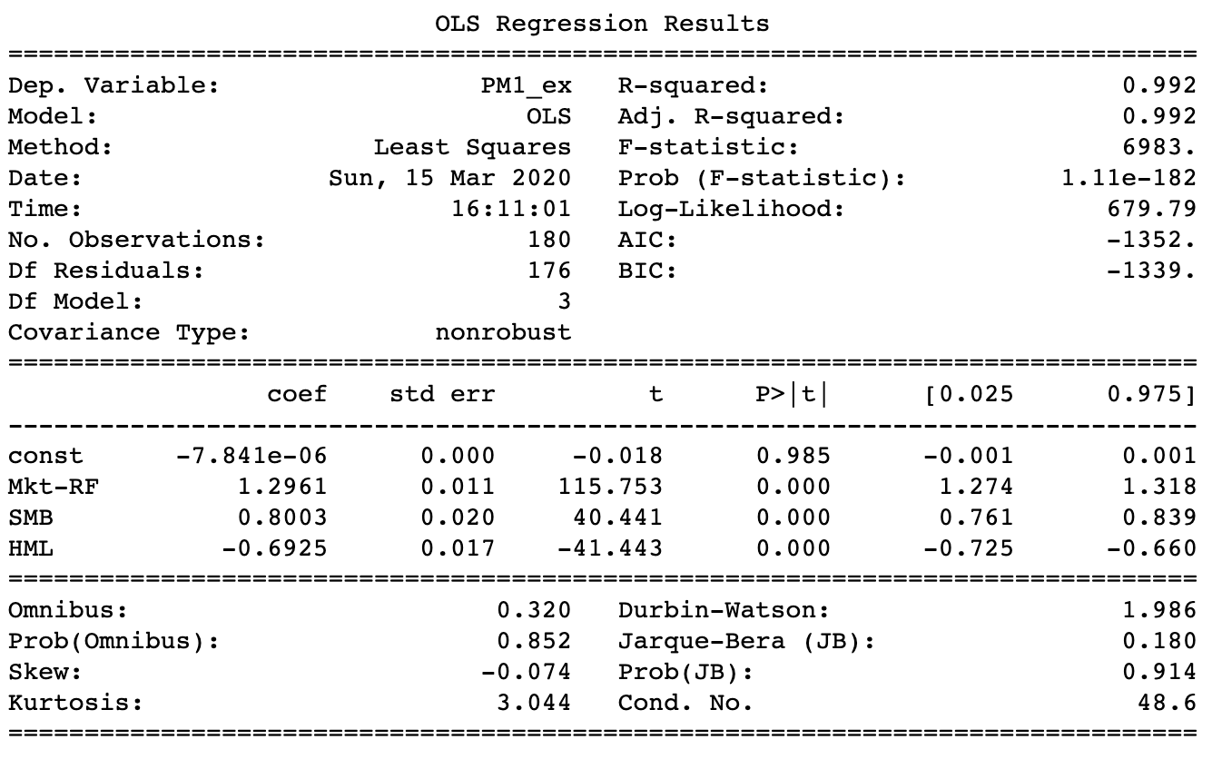

For the second manager we have the following result:

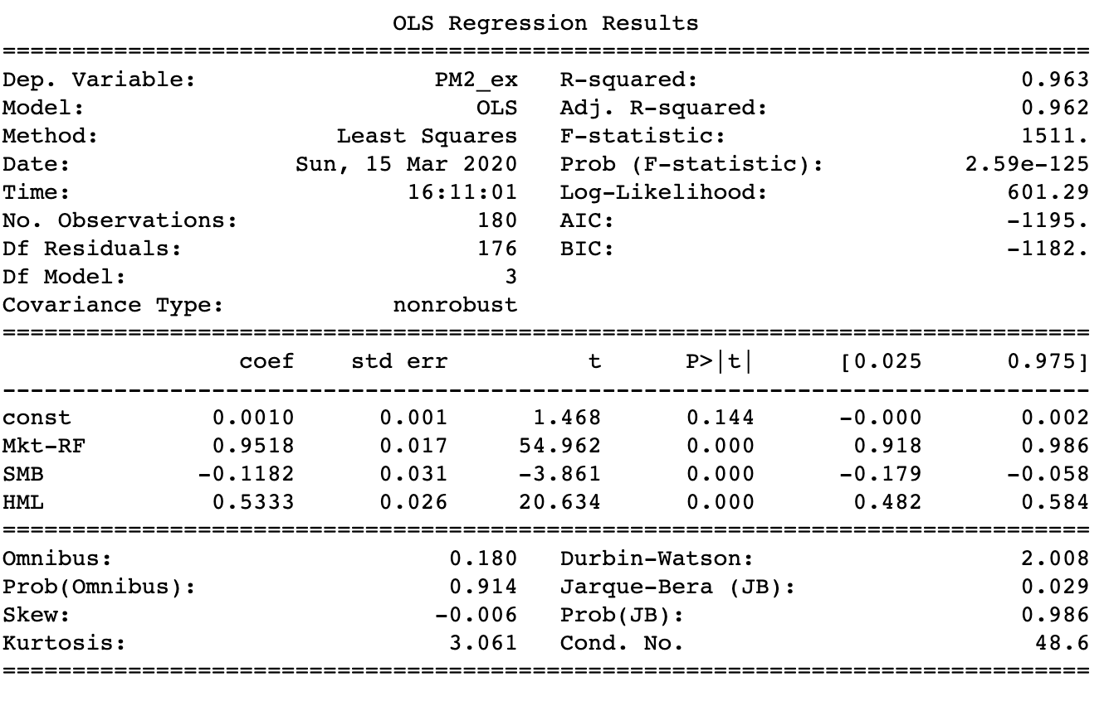

Here we can see that again the alpha is very small and insignificant, suggesting that market excess returns and the factors explain the excess returns produced by this manager. We can also observe that the R-squared is very high 96.3% and was 99.2% for the previous manager, suggesting that Fama-French model can almost completely explain the excess returns produces by these managers. In this case, we can see that the loading on the SMB factor is negative, which means that this manager does not include SMB in his/her strategy.

**Part C**

To understand which PM is better at beating the market, we perform a difference in means test, to understand if their expected excess returns are significantly different from each other or not.

$$H_{0}:μ_{1}=μ_{2}$$

$$H_{1}:μ_{1}≠μ_{2}$$

In this case, the variance of the mean excess returns is taken to be the unbiased variance of the excess returns. Using the central limit theorem, we would have that the test statistic for this hypothesis is normally distributed which we calculate by the following formula

$$Test Statistic= \frac{{\overline{μ}}_{1}- {\overline{μ}}_{2}}{\sqrt{\frac{σ_{1}^{2}}{T}+\frac{σ_{2}^{2}}{T}}}$$

We obtain that our test statistic is 0.557 which is less than 1.96. Hence, we would fail to reject at 5% significance level that the two mean excess returns are not equal. This result is expected since we saw from the above regressions that alphas for both managers were very close to zero and insignificant.

In order to understand, whether the Sharpe ratios of both managers are different from each other and whether one is higher than the other we have the following hypothesis:

$$H_{0}:{SR}_{1}={SR}_{2}$$

$$H_{1}:{SR}_{1}≠{SR}_{2}$$

We define

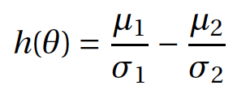

To be the difference in Sharpe Ratio estimates for both managers, hence according to the standard GMM estimation, the asymptotic variance-covariance matrix of $h\left(\hat{θ}\right)$ would be $\hat{Ω} = \frac{\hat{V}}{T}$ where

$$\hat{V}={(\hat{d}'{\hat{S}}^{-1}\hat{d})}^{-1}$$

And $\hat{d}$ is

$$\frac{∂\hat{E}(h\left(θ\right))}{∂θ'}=\begin{matrix}-1 & 0 & 0 & 0 \\ 0 & -2\hat{σ_{1}} & 0 & 0 \\ 0 & 0 & -1 & 0 \\ 0 & 0 & 0 & -2\hat{σ_{2}}\end{matrix}$$

We have that

$$\hat{S}=E(h\left(θ\right)h{\left(θ\right)}^{'})$$

From the above we obtain that

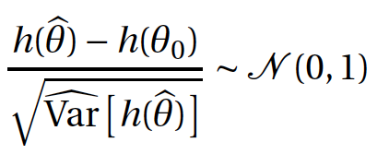

Hence, our test statistic with these calculations is 0.011 and we fail to reject that the Sharpe Ratios of these managers are different from each other.

We further perform a test to determine whether the Information Ratios are the same for both managers:

$$H_{0}:{IR}_{1}={IR}_{2}$$

$$H_{1}:{IR}_{1}≠{IR}_{2}$$

We perform the same two sample t-test as we did above for the means, using the fact that the variance of the information ratios can be used as the standard error of the alphas from the regressions, which is due to the fact that we can treat the standard errors of the residuals as constant. We have the following test statistic

$$Test Statistic= \frac{{\hat{IR}}_{1}- {\hat{IR}}_{2}}{\sqrt{\frac{σ_{1}^{2}}{T}+\frac{σ_{2}^{2}}{T}}}$$

And obtain that it is equal to -14.10, hence we can reject the null hypothesis with 1% significance level that the information ratios of both managers are not equal to each other.